Emil Fernando   
Nivedhitha Pandi Kadavil

MASTER THESIS 2025

Master in Built Environment with a specialization SUSTAINABLE BUILDING INFORMATION MANAGEMENT

**An Ontology-Based Approach to Integrating Digital Product Passport Data into Enterprise Asset Management Systems**

This thesis work has been carried out at the School of Engineering in Jönköping in the subject area Built Environment - Sustainable Building Information Management. The work is a part of the Master of Science with a major Built Environment, specializing in Sustainable Building Information Management.

The authors take full responsibility for opinions, conclusions and findings presented.

Examiner: Annika Moscati

Supervisor: Rahel Kebede

Co-Supervisor: Mathias Bjerkliden, Simon Sjöberg, Mattias Endredi

Scope: 30 credits (second cycle)

Date: 2025/06/12

**PHONE:** *+46 (0)36 10 10 00*

**WEB:** *www.ju.se*

**ADDRESS:** *School of Engineering, P.O Box 1026, SE-551 11 Jönköping, Sweden*

**VISIT**:*Gjuterigatan 5, Campus, Building E*

**An Ontology-Based Approach to Integrating Digital Product Passport Data into Enterprise Asset Management Systems**

**Emil Fernando,** [feem23cx@student.ju.se](mailto:feem23cx@student.ju.se)

Jönköping University, Jönköping 551 11, Sweden

**Nivedhitha Pandi Kadavil,** [pani23up@student.ju.se](mailto:pani23up@student.ju.se)

Jönköping University, Jönköping 551 11, Sweden

Abstract

Digital Product Passports (DPPs), a recent initiative by the European Union (EU), aims to improve product traceability, transparency, and sustainability to facilitate the circular economy. DPPs contain lifecycle data that has the potential to reduce fragmented data in Enterprise Asset Management (EAM) systems. However, the integration of DPPs presents challenges for existing technical infrastructures, often requiring system development or adaptation. This study presents an ontology-driven integration framework to incorporate DPP data into EAM systems. The research combines a literature review, survey, and interviews to identify integration challenges and requirements. A modular ontology was developed to formally represent DPP information. Building upon this ontology as the foundational layer, a semantic integration architecture demonstrates the implementation of the system that uses a triple store and REST APIs to connect the EAM system with DPP databases. The proposed DPP ontology was instantiated with sample data to demonstrate and validate the integration approach. Findings indicate that the proposed integration is well supported for its ability to reduce fragmented data, asset traceability, and regulatory compliance while meeting industry requirements. The study provides a semantic bridge between DPP and an EAM system, enabling organizations to leverage product lifecycle data for more informed decision-making while simultaneously laying a foundation for sustainable asset management practices.

Keywords

Digital Product Passport, Enterprise Asset Management, Data Integration, Interoperability, Modular Ontology, Semantic Web, RDF/OWL Knowledge Graph.

# Introduction

The Eco-design for Sustainable Products Regulation (ESPR) introduced the Digital Product Passport (DPP) as an initiative within the European Union’s sustainability framework. This initiative supports the European Green Deal and Circular Economy Action Plan (CEAP) to achieve the goal of becoming the first carbon-neutral continent by 2025 (European Commission 2020, 2021). DPPs will be mandatory for all the regulated products on the European Union (EU) market, providing access to product information to enhance the traceability, transparency, and their lifecycle (European Commission 2025), This aims to reduce waste, promote sustainable consumption and ensure circularity, facilitating the transition to a carbon neutrality and a circular economy (CE) (Zhang and Seuring 2024, Wan and Jiang 2025). The DPP is a digital identity card that stores and shares information about a product (European Commission 2025), for example, the origin composition, used instructions, repair instructions, and dismantling procedures (Palm *et al.* 2024). DPPs have been defined as a container that integrates heterogeneous data from a product’s lifecycle phases (Koppelaar *et al.* 2023). The ESPR highlights that product information should be accessible electronically through a data carrier such as a Watermark, Quick Response (QR) code, Radio Frequency Identification (RFID) tag, which should be considered in DPP development (Regulation (EU) 2024/1781 2024, Wan and Jiang 2025). The product’s information in the DPP will be shared transparently through its whole lifecycle to benefit several stakeholders. It can provide deeper insights into a product to improve the decision-making process for consumers, businesses, and regulators regarding the purchase of new or used products. It further facilitates repairs and recycling by obtaining both dynamic and static product information (Wijewickrama *et al.* 2021, Wan and Jiang 2025). The knowledge gained from analyzing DPPs is expected to contribute to achieving a CE. This can be accomplished by offering information on various R-strategies (e.g., repair, refurbish, remanufacture, and recycle) or by providing digital services for the relevant products (e.g., predictive maintenance) (Jansen *et al.* 2023). DPPs improve transparency and allow for the exchange of data related to the product across network partners (Spiss *et al.* 2024).

Due to an increase in the quantity of data in organizations, integrating tools improves coordinating maintenance operations, and managing the information for making decisions (Gorski *et al.* 2022). Modern industrial architectures require a collaborative and cooperative atmosphere where products, machines, and systems can exchange data (Shi *et al.* 2020). Enterprise asset management (EAM) systems are used by companies that manage, maintain, and repair physical assets efficiently throughout their lifecycle (Gorski *et al.* 2022, Singh and Pekkola 2023). The majority of Enterprise Systems are cloud-based services; on the other hand, EAM systems are delivered as a packaged system and locally installed (Singh and Pekkola 2023). The limitations have influenced the organizations to customize their EAM system for maintenance and support, implementation, or upgrading purposes, or business scenarios (Singh and Pekkola 2023). Incompatibilities between the functionalities offered by a software package and specific requirements by the organization are referred to as misfits. For example, data misfit can be caused by incompatibilities from the relationships among entities represented in a data model or by the organizational requirements and the software package regarding data formats. To address these misfits between a software package and an organization, can be solved in two ways: a) Adapting to new functionalities or b) Customizing the software package (Singh and Pekkola 2023). Reasons highlighted by Singh and Pekkola (2023) for customizing an EAM system were: (i) Regulatory need; (ii) Missing product features; (iii) Slow enhancement implementation; (iv) Communication gap between customers and consultants; (v) Too easy to customize. Additionally, to improve the value of DPPs and to make a smooth integration into an existing operating system, the integration method needs to be advanced(Spiss *et al.* 2024).

Regulation (EU) 2024/1781 (2024) states that all the data included in DPPs should be based on open standards, developed in an interoperable, machine-readable, structured, searchable format. The implementation of DPPs with open data principles (European Union 2024) aligns closely with linked data principles (Kebede *et al.* 2024), to present structured data on the web using standard formats. Semantic web technologies support the linked data principles by integrating product information from different sources, thereby overcoming interoperability challenges (Pauwels *et al.* 2017). While research shows advantages of DPPs, Singh and Pekkola (2023) highlights the lack of research attention to EAM systems. The technical infrastructure of the existing systems may face challenges regarding the integration of the data in DPPs, as it requires development or adaptation of new systems and technologies to support the creation, storage, and sharing of the data (Yu *et al.* 2023). To address that challenge, this research study proposes a model to integrate DPP data into an EAM system, using Linked Data principles and Semantic technologies. This study addresses the research question *“How can Digital Product Passport (DPP) data be integrated into Enterprise Asset Management (EAM) systems using ontologies to enhance asset management?”*. The contribution of this research is to lay a foundation for integrating a modular ontology-driven DPP into the EAM system and its contribution to improve decision-making, supporting sustainable asset management, promoting CE, and ensuring regulatory compliance. Utilizing an ontology approach overcomes challenges related to fragmented data and interoperability in implementing DPP data, enabling a more efficient, scalable, automated, and sustainable enterprise system.

The following outline of this paper covers: Conceptual background in Chapter 2, Methodology in Chapter 3, Results in Chapter 4, Discussion in Chapter 5, and Conclusion in Chapter 6.

# Conceptual background

This chapter highlights the main concepts gathered from the literature review and is divided into three sub-chapters: Data standardization and interoperability of DPPs in Chapter 2.1, Ontologies and Knowledge Graphs for interoperable DPPs in Chapter 2.2, and DPPs in EAM systems and maintenance in Chapter 2.3.

## Data Standardization and Interoperability

The product data in DPPs needs to have a standard structure to ensure interoperability and reusability(Pourjafarian *et al.* 2023). However, data interoperability is more than a technical issue: as both Magas and Kiritsis (2022), and Jansen *et al.* (2023) states, it’s also conditional on ethical, cultural, regulatory, environmental, and societal parameters, not only on technical, semantic and FAIR (findable, accessible, interoperable, and reusable) aspects. For DPP implementation, a standardized framework provides clear guidelines, specifications, and effective methods for the users to have a common understanding and to share the relevant information across the systems and digital platform (Walshe *et al.* 2023). The standardized approach for accessing and sharing information can benefit different stakeholders to use different data according to their needs (Kebede *et al.* 2024). Chaudhuri *et al.* (2024) further highlights that a single company cannot collect data, ensure data standards, and interoperability between systems due to the increased need for data and standardized frameworks. Therefore, a standard technical infrastructure of DPPs is needed to allow seamless integration across a company’s system. With no regulations and standards of DPP implementation, it may become uncoordinated, resulting in discrepancies and limiting the potential benefits (Götz *et al.* 2022) and creating confusion among users and limiting the interoperability of DPPs (Plociennik *et al.* 2022). It is beneficial to develop a product information using semantic standards to enhance the interoperability, formats, data exchange protocols, and data processing within the DPP framework (Walshe *et al.* 2023).

## Ontologies and Knowledge Graphs for Interoperable DPPs

Ontology languages form a standard that represents, organizes, and exchanges data in a searchable, machine-readable, and understandable format. An ontology formally represents concepts and relations in a domain by combining heterogeneous data from diverse sources and providing a common language. Each concept's properties define its features, attributes, and constraints (Kebede *et al.* 2024) providing a framework for handling queries regarding data (Montero Jiménez *et al.* 2023). Ontologies and semantic web technologies simplify data exchange and interoperability among different systems (Montero Jiménez *et al.* 2023, Kebede *et al.* 2024). The semantic web and linked data community has developed standardized knowledge representation languages that are based on formal logic to present various levels of reasoning capability and expressiveness (Kebede *et al.* 2024). Semantic web technologies and linked data have produced significant results regarding the integration of heterogeneous data. Overcoming interoperability challenges has been identified as a driving factor for its adoption in the Architecture, Engineering, and Construction (AEC) industry (Wagner and Rüppel 2019, Kebede *et al.* 2022). The linked data principles align with the EU´s open data principles that emphasize openness, transparency, interoperability, and reusability of data. In addition, the interoperable format and standards are beneficial for DPPs to be a flexible and reliable solution for its implementation and to meet the requirements of CE (Kebede *et al.* 2024). Similar hypothesis have been drawn by Gligoric *et al.* (2019), Sauter *et al.* (2019), and Kedir *et al.* (2023).

Ontologies serve as a base for knowledge graphs, keeping the data and its model consistent and clear, and it allow reusable and shareable knowledge representation (D’Cruze *et al.* 2024). A knowledge graph (KG) can link different data models and formats from various sources without changing their original form by connecting the knowledge (Wilcke *et al.* 2017). It uses graph-based models containing nodes to describe relations between entities that are captured with defined edges and labels. This provides transparency, collaboration, and innovation with involved stakeholders in the value chain (Kebede *et al.* 2023). A thorough understanding of the product’s material, components, functions, and previous interaction with users enables stakeholders to make informed decisions about the product, with DPPs being implemented in KGs. The detailed overview of the product’s features, history, information regarding the environmental impacts, associated costs, and the availability of spare parts can be modelled in KGs, to improve the decision-making process by deciding whether to repair, remanufacture, or recycle a product based on the information from a DPP (Kebede *et al.* 2023). In this study, ontologies serve as the backbone for structuring DPP data, while a knowledge graph (triple store) is used for connecting heterogeneous data in human and machine-interpretable structures. Combining a standardized structure and FAIR principles supports consistency in data to be effectively interoperable with existing systems.

## Digital Product Passport in Enterprise Asset Management and Maintenance

EAM systems, which provide a broader and a more integrated approach to asset lifecycle management, have developed from Computerized Maintenance Management System (CMMS), which were originally designed to manage maintenance tasks, such as planning and managing work orders. More recently the term EAM has been more adopted to reflect its broader and more strategic focus (Polenghi *et al.* 2021). The selection and review of the maintenance strategy needs to consider both traditional and current trends that focus on utilizing the advanced analysis and prediction tools to initiate maintenance actions (Montero Jiménez *et al.* 2023). Choosing an inappropriate maintenance approach for equipment can result in problems like unpredictable product quality, reduced energy efficiency in certain areas, and inefficient distribution of maintenance workers. With these reasons, most companies are taking initiatives to improve the performance of the maintenance function of their physical assets (Werbińska-Wojciechowska and Winiarska 2023). King *et al.* (2023) emphasize that stakeholders within maintenance-focused organizations are generally supportive of a system that provides product handling information regarding operation, maintenance, and service of the product. CMMS/EAM provides valuable data, but those are rarely analyzed (D’Cruze *et al.* 2024). Developing an ontology to define how CMMS/EAM data is collected and organized could help to improve in analyzing the data effectiveness, as most of the data in CMMS/EAM is in free-text format and is difficult to analyze without human presence (D’Cruze *et al.* 2024). Ontologies have already been applied in maintenance, and formal terminology frameworks have been created to assist tasks such as maintenance management, condition monitoring, prognostics, and health management (Montero Jiménez *et al.* 2023).

Similar source systems to EAM, such as Enterprise Resource Planning (ERP), Asset Lifecycle Management (ALM), and Product Lifecycle Management (PLM). These systems can provide and connect the latest data through Representational State Transfer (REST) Application Programming Interface (API). To enable such integration, the new data (e.g., data in a DPP) needs to be programmed or converted to an appropriate programming language according to the source system’s API (Eickhoff *et al.* 2020). Haghighatkhah *et al.* (2017) states that EAM/CMMS systems need to take advantage of the product data and using it as beneficial information, hindering better decision making. Therefore, it’s important that the information contained in the DPPs is structured and encoded in ways that allows for alignment and easy integration with the technical infrastructure of all systems (Walshe *et al.* 2023, Spiss *et al.* 2024). Understanding the current limitations and data challenges in EAM systems validates the need for the proposed ontology-based integration to address data fragmentation to improve decision-making.

# Research Methodology

This chapter describes the research methodologies used in this study. The methodologies are selected based on their suitability for addressing the research objective. Chapter 3.1 covers the literature review process, Chapter 3.2 covers empirical data collection, Chapter 3.3 describes the ontology development using the Modular Ontology Modelling (MOMo) workflow, Chapter 3.4 describes the system integration framework development.

## Literature Review

A scoping review was conducted to understand the state of art in the AEC industry regarding DPPs, EAM systems, and how the DPP data can be integrated into an EAM system. The PICOC framework (Table A1 in Appendix) is used to develop clear, important keywords, scope, and research area outlined by Booth *et al.* (2012). The research question formulated led to the development of the following search concept (Table 1) and strategy (Table A2 in Appendix). The search queries use the Boolean Operator “OR” to expand the search field. Subsequently, the Boolean Operator “AND” is used to find combinations to retrieve relevant papers for the research topic.

Table . Search Concept and its synonyms.

|  |  |
| --- | --- |
| **Search Concept** | **Synonyms** |
| C1 - (Product Data) | ("Digital Product Passport" OR "Digital Product Identity" OR "Product Data Passport" OR "Product Passport" OR "material passport" OR "digital traceability" OR "Product Lifecycle Management") |
| C2 - (Enterprise Asset Management) | ("Enterprise Asset Management" OR "EAM” OR "Enterprise resource management" OR "Asset Management System" OR "Asset Lifecycle Management" OR "Maintenance Management System") |
| C3 - (Integration & Implementation) | ("Integration" OR "Implementation" OR "Merging" OR "Deployment" OR "Data Integration" OR "Data Implementation" OR standard) |
| C4 - (Sustainability) | ("Sustainability" OR "Sustainable Development" OR "Environmental Sustainability" OR "Eco-friendly” OR "Resource Efficiency" OR Circularity) |
| C5 - (Operational Efficiency) | ("Operational Efficiency" OR "Operational Effectiveness" OR "Process Optimization" OR "Performance Improvement" OR "Cost Efficiency" OR "Resource Optimization" OR "Operational Performance") |
| C6 - (Semantic Web and Link Data technologies) | ("Ontolog*" OR "Knowledge Graph" OR "Semantic Representation" OR "Linked Data" OR "Semantic Web*" ) |

Relevant papers were collected from the database Scopus, a source for citation data and peer-reviewed papers (Mongeon and Paul-Hus 2015). To acquire the most recent information about DPPs, Semantic technologies, EAM system, and Integration strategies, the literature review focused on English papers with a publishing span between 2020-2025. A total of 513 papers were exported in a RIS format to a reference manager program. The duplicates were deleted, leading to a total of 208 moving on to the screening process. 111 papers were excluded from the title screening, and 62 papers from the abstract, since it didn’t align with the research scope. One paper was behind a paywall and therefore couldn’t be retrieved, excluding it from the eligibility stage. After full text review, 16 more papers were excluded for not meeting the inclusion criteria. Additional five papers were included by both snowballing the reference list and based on their relevance and contribution to the research objective, leading to a total of 23 papers that were selected for review. The PRISMA flowchart illustrating the paper selection process is provided in Appendix (Figure A1).

The selected studies were synthesized thematically, resulting in three key themes: (i) Integration challenges and requirements in DPP and EAM, (ii) The role of semantic technologies and ontologies for data interoperability, (iii) System architecture and data standardization for DPP implementation. These themes guided the development of the proposed integration framework presented in the result Chapter 4.1.

## Empirical Data Collection

Empirical data were collected through semi-structured interviews, and a survey to gain deeper industry insights and expectations regarding a feasible modular ontology-driven DPP integration. The respondents and participants were industry professionals from a large globally operation engineering, advisory and consulting services company with over 75 000 employees.

### Survey

To gather industry insights, a survey was conducted to recognize the familiarity of the DPP concept, benefits, potential application areas, industry readiness, and willingness for an ontology-based DPP integration in EAM systems. The survey was developed following Taherdoost (2018) guidelines. The survey consists of 18 questions, divided into 5 sections, and aims to address industry knowledge, expected challenges, barriers for adoption, and expected outcomes of an ontology-driven approach regarding DPP-EAM integration. To get a diverse industry representation, the survey questionnaire was published on a company’s social networking platform Viva Engage, used by industry professionals in the built environment. Observation from the survey provides insights into for an integration, focusing on challenges in the EAM system, the role of ontologies, and the perception of a possible DPP-EAM integration. The entire set of survey questions are available in the GitHub repository referenced in *Data Availability* chapter and the corresponding results are discussed in Chapter 4.2.

### Interviews

To complement the survey data and acquire a deeper qualitative understanding, semi-structured interviews were developed and conducted, following the approach outlined by Kebede *et al.* (2024). The aim of the interviews was to gain perspectives on current limitations in the EAM system, integration needs, and expectations regarding the DPP-enabled EAM system. Twelve core questions, followed by sub-questions were constructed to identify gaps, suggest best practices, and refine integration strategies for. The interviews also served to validate key assumptions derived from the literature review and survey findings. A summary of the participants can be found in Appendix (Table A3) and the set of interview questions are available in the GitHub repository. The main insights from the interviews are discussed in the results Chapter 4.3.

### Ethical Considerations, Data Handling, and Analysis

The participants were informed about the purpose of this research, and that their anonymity and confidentiality were preserved. The survey responses were collected using forms, while the interview responses were documented through recording and transcribed for accuracy. The results of the survey were analyzed manually by the authors, and the transcribed interview summaries were thematically analyzed. Findings from both methods were combined to support and the development of the proposed integration framework.

## Ontology Modelling Workflow

The MOMo workflow methodology presented by Shimizu *et al.* (2023) is applied to develop the modular ontology in a structured and reusable manner, aligned with stakeholder needs and expectations from the survey and interviews. For the development of DPPs for EAM systems, the MOMo workflow plays a vital role in guiding how to address reuse or adapting ontologies for a new use case or purpose. It also defines processes for creating modular ontologies, which is a more suitable approach, in this context for developing DPPs since it contains a large amount of data (Kebede *et al.* 2024). The modular ontology for was developed using the software Protégé and Python to exemplify data in a DPP. The resulting modules and ontology will be presented in Chapter 4.4. The complete documentation of the MOMo methodology is available in the GitHub repository[1].

## System Integration Framework

To conceptualize the integration of DPPs with EAM systems, a framework was developed based on findings from the literature, survey, and interviews, aiming to address issues of data fragmentation, lack of interoperability, and scalability concerns. The modular ontology structured DPP will serve as the foundation, which enables semantic clarity, extensibility and reusability. This is supported by semantic web technologies and standard data exchange protocols to ensure interoperability across systems. The framework was modeled to demonstrate how lifecycle product data in a DPP can be semantically structured, queried, and synchronized across platforms. The resulting architecture is presented and discussed in Chapter 4.5.

# Results

The following chapter presents the results of the study. Literature review results in Chapter 4.1, Survey results in Chapter 4.2, Interview results in Chapter 4.3, Ontology Development and Evaluation in Chapter 4.4, System integration framework Chapter 4.5.

## Literature Review Findings

A summary of the three themes identified through the literature review (Chapter 3.1) is presented in Table 2. These findings align with this study’s scope, providing the basis for semantic structuring, interoperability, modular ontology, integration framework, and system compatibility.

Table 2. Identified thematic focus areas and findings for DPP integration with the EAM system

|  |  |  |
| --- | --- | --- |
| **Theme** | **Key Findings** | **References** |
| Integration challenges and requirements in DPP and EAM | **Challenges**: Interoperability of enterprise systems, EAM customizations and limitations, Maintenance systems and infrastructure, Bidirectional Integration with systems and event-driven architecture, Reverse logistics and reuse strategies, System integration. Transparency.  **Requirements**: Traceability, Lifecycle data and circularity, Access authorization and data rights, Digital identity and portability, Sustainability regulations. | (Eickhoff *et al.* 2020, Chen and Chen 2022, Gorski *et al.* 2022, Jansen *et al.* 2023, Kebede *et al.* 2023, 2024, King *et al.* 2023, Koppelaar *et al.* 2023, Pourjafarian *et al.* 2023, Singh and Pekkola 2023, Werbińska-Wojciechowska and Winiarska 2023, Chaudhuri *et al.* 2024, D’Cruze *et al.* 2024, Palm *et al.* 2024, Spiss *et al.* 2024, Zhang and Seuring 2024, Wan and Jiang 2025) |
| The role of semantic technologies and ontologies for data interoperability | Semantic interoperability and shared vocabularies, Linked Data and FAIR principles, Ontology design patterns, Modular ontologies and reuse, Knowledge graphs and semantic reasoning, Graph-based models and RDF/SPARQL queries, Standard and product alignment, Application in product modelling, Machine-understandable product data. | (Wagner and Rüppel 2019, Eickhoff *et al.* 2020, Polenghi *et al.* 2021, Kebede *et al.* 2022, 2023, 2024, Magas and Kiritsis 2022, Jansen *et al.* 2023, Montero Jiménez *et al.* 2023, Pourjafarian *et al.* 2023) |
| System architecture and data standardization for DPP implementation | Standardized APIs and open data structures, Modularity and decentralized storage, Data right and secure access management, Pilot implementation and scalability, Interoperability across industry verticals, Integration of lifecycle systems, Supportive infrastructure and identity verification, Digital product linkage and unique identifiers, Enables smart workflows in EAM. | (Eickhoff *et al.* 2020, Shi *et al.* 2020, Polenghi *et al.* 2021, Chen and Chen 2022, Gorski *et al.* 2022, Magas and Kiritsis 2022, Jansen *et al.* 2023, Kebede *et al.* 2023, 2024, King *et al.* 2023, Pourjafarian *et al.* 2023, D’Cruze *et al.* 2024, Spiss *et al.* 2024, Wan and Jiang 2025) |

## Survey Results

The survey aimed to gain industry perceptions on current asset data management, challenges, and valuable aspects of a DPP-enabled EAM system. Most of the survey respondents represented the infrastructure sector, followed by construction and energy & utilities. In total, around 80% of the 38 respondents have familiarity with EAM systems. Most respondents use the EAM system for tracking *Asset location*, *Maintenance history*, *Manufacturer and supplier data*, while the minority use it for *Lifecycle performance data*, *Material composition,* and *Environmental impact data*. Five respondents mentioned that they don’t use EAM systems. The results (displayed in Figure 1) indicate that the majority of respondents still use *manual entry methods* to manage asset-related data, and *structured databases*, with a limited amount using *Linked Data/Semantic web technologies*. Observing the top three challenges faced in asset management regarding lifecycle data is *Data inconsistency across departments*, *Lack of standardized data*, and D*ifficulty in tracking asset maintenance history*. This suggests a potential link between manual processes and data inconsistency.

~~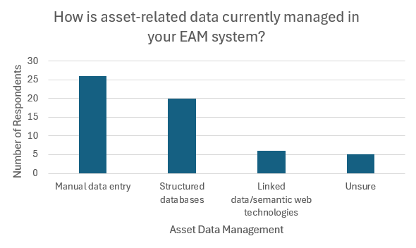~~ ~~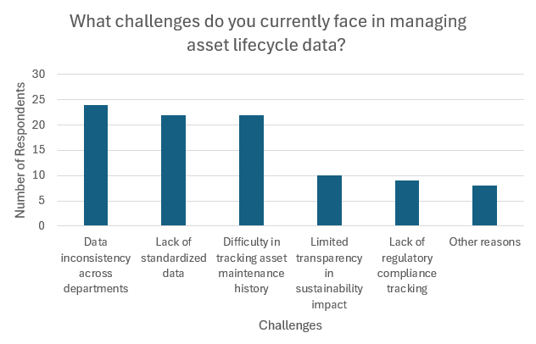~~

Fig. . Data management in EAM system (left) and challenges in managing asset lifecycle data (right)

Figure 2 outlines the identified benefits of an ontology-driven approach for DPP integration. The most frequent response (38%) was the need for *more structured and queryable data representation*, followed by *enhanced automation in asset data management* (30%) and *improved semantic interoperability between systems* (22%). From the results the semantic approach is seen as critical enablers for reducing data fragmentation and increasing data usability, consistency, and automation within enterprise asset management workflows. Figure 3 presents the main aspects of DPP-EAM integration that the respondents consider most valuable. The respondents identified key reasons for integrating DPPs into EAM systems, the main drivers includes: (i) improved traceability of assets; (ii) standardize of product information across suppliers; (iii) provide transparency in sustainability metrics and circular economy data; (iv) enable real-time tracking of maintenance and repairs; (v) enhance regulatory compliance and reporting.

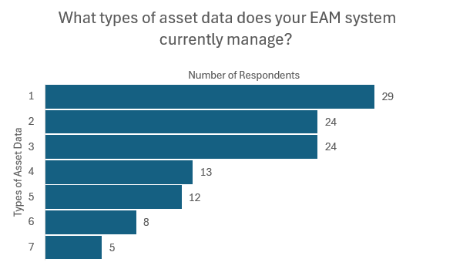

Fig. 2. Identified benefits of an ontology- Fig. 3. Aspects of DPP integration considered  
driven approach to DPP integration valuable for asset management

According to the survey, the respondents indicated a high level of agreement that DPPs have the ability to improve asset traceability, resulting in a median value of four on a five-point scale. Most participants rated the DPP-EAM integration as beneficial for improving traceability, sustainability efforts, and decision making. Another notable finding is that the respondents who recognized the importance of sustainable strategies in asset management also believe that DPPs can contribute towards a circular economy. Although the industry recognizes potential in DPP integration, several concerns remains. The common challenges recognized were; (i) a *Lack of industry-wide standards for DPP data*; (ii) *Organizational resistance to adopting new technologies;* (iii) *Cost of implementation and system upgrades*; (iv) *Technical complexity and IT infrastructure limitations*; (v) *Security concerns over data sharing*. The complete survey responses are available in the GitHub repository[2].

## Interview Results

To complement the survey findings, five semi-structured interviews were conducted. The interviews were held either in person or online, depending on the availability of the interviewee and the authors. At the request of participant B, one interview was conducted in Swedish, while the remaining interviews were conducted in English. All participants acknowledged that DPPs can benefit, maintenance work, product traceability, lifecycle data management and sustainability. Participant A underlined that DPPs could improve traceability and lay a foundation for automating product lifecycle management by displaying outdated assets. Similar statements about predictive maintenance were highlighted by participant B, Participant C highlights that DPPs are seen as an extension of current practices regarding asset tracking, transparency, and sustainability reporting. Participant D emphasized DPPs role to improve lifecycle assessments, traceability, and noted that DPP practices are already in use in France. Participant E describes the EAM system as easy to customize and capable of attaching requested data or additional information. Currently, the API is mainly utilized for integrating product data through spreadsheets that rely on manual input data.

The participants share a similar view on integrating DPPs with EAM systems and accessing product data through the mobile with scanning (e.g., QR/bar-code). Adopting a standardized data framework, semantic structuring and interoperability, and leveraging Internet of Things (IoT) connectivity to enable feedback loops for operational efficiencies and predictive maintenance were recommended by the interviewees. Through the IoT connectivity, the DPP-enabled EAM system supports bi-directional data transfer. Additionally, role-specific data access is also highlighted to only receive relevant information within their scope of work, while allowing limited access to additional data when necessary or required.

However, divergences appear in implementation readiness, data governance practices, and technological familiarity. Participant E considers the EAM system to have all the necessary data information but mentioned that it would be useful for field workers to access data from a DPP-enabled EAM system out in the field for direct work-related information. Both participants A and D had similar views on inconsistent and fragmented data, reliance on static documentation, and, in some instances, the data is not machine-readable. Participant D further underscores that an integration will require additional work, effort, training, and organizational adjustment to a new process. Some sectors are more advanced in asset tracking and driven by strict compliance requirements compared to the preserved approach that relies on internal standards described by participant B. The interview summaries are available in the GitHub repository.

## Ontology Development and Evaluation

Following the MOMo methodology, the ontology (dpp4eam) was developed to represent DPP data for EAM systems. The ontology is divided into eight interoperable modules[3] (shown in Figure 4), framed by the grey boxes. Each module consists of reused, modified, or newly created ODPs suitable for the ontology. The intention of the ontology is to enable future DPP development to use a modular structure and for them to be suitable for EAM systems. Due to the page limit criteria of producing this paper, the ontology development is demonstrated and explained thoroughly in the extended version of this paper and is accessible from the GitHub repository.

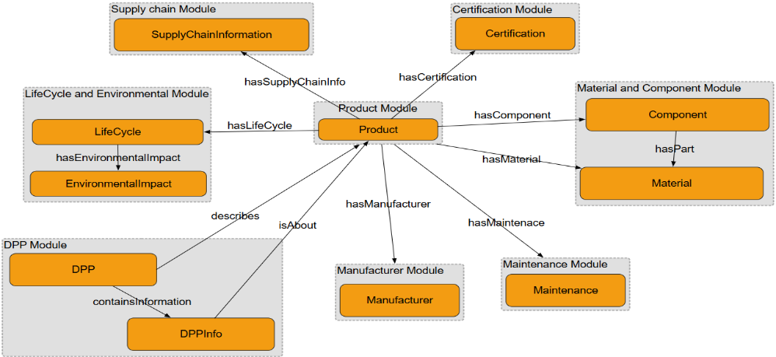

Fig. 4. Modules in dpp4eam ontology

Throughout the modular ontology development process, the reasoner Pellet was used to ensure classes and properties could be instantiated without any conflicting assertions. Running a reasoner enables verification that the ontology satisfies the restrictions and is free of incompatible axioms. An instance was created to simulate relevant product information that could be represented in a semantically structured DPP. SPARQL queries were executed to simulate how an asset manager would retrieve data from a triple store.

## Proposed System Integration Framework

Figure 5 illustrates the proposed System Integration Architecture (DPP-EAM), which links semantically structured product information to an EAM system (IBM Maximo) through a REST API-driven data integration framework. The architecture is designed to support a seamless integration, transformation, validation and utilization of DPP data across the system. The workflow starts with a set of distinct data modules, each containing a specific dimension of product or asset related information. The modules include Product, Maintenance, Manufacturer, Material and component, Lifecycle and Environmental impact, Certification, and Supply chain. Each module functions independently and can be customized according to the requirements of domain or organization. All these modules are then assembled into a DPP, which is a unified digital record, that consolidates all relevant product information in a machine-readable and interoperable format. When the DPP is fully assembled, it is then assigned a unique URI and imported into a triple store (GraphDB). The system stores the data in formats such as RDF, OWL, Turtle, and JSON, which allows to model complex relationships and enables semantic querying and reasoning. To enable the exchange of data between GraphDB and IBM Maximo REST API is utilized. The REST APIs act as interfaces between the DPP data source and the EAM system to realize the integration. The interfaces use standardized data schemas (e.g., JSON, XML) based on the APIs offered by the EAM system and enables CRUD (Create, Read, Update, Delete) operations, thus supporting periodic synchronization. A transformation layer is implemented for aligning the semantic mapping between the DPP data into an EAM system. For example, if a product in the DPP is defined as “Product”, and IBM Maximo defines it as “MXASSET”, then the mapping will not be recognized as an equivalent class unless it’s established in the ontology or through a data transformation layer. By having a data transformation layer, both redundancy and inconsistencies can be eliminated, ensuring consistency among modules and enabling the scalability of data. IBM Maximo, can access the enriched DPP data through a user interface, providing the users the visibility into asset status such as maintenance, certification, lifecycle information etc. The system will allow the users to review the data and to make updates as required. These updates are sent back through the system to keep the RDF triple store and the DPP to be up to date and aligned. This architecture offers a structured, scalable and semantically enriched approach for integrating products lifecycle information into an EAM system such as IBM Maximo.

~~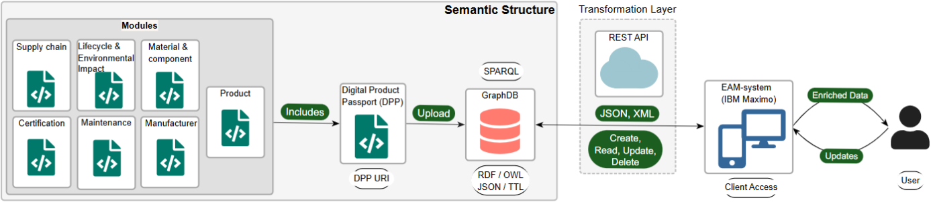~~

Fig. 5. Integration System Architecture (DPP-EAM)

# Discussion

This paper addresses how modular ontology-driven DPPs can be integrated semantically into an EAM system to improve data interoperability, traceability, and decision making. Findings from the survey indicate that many industry professionals use manual workflows and siloed databases, while a minority utilize Semantic data/Linked Data technologies in their EAM system. This results in a lack of standardized data, difficulty in tracking asset maintenance history, data inconsistency across departments, limited transparency in sustainability impact, and a lack of regulatory compliance tracking.

Similar issues were also identified by Singh and Pekkola (2023), who also mentioned misfits between packaged systems and organizations’ demands lead to customization, particularly around missing product data, regulatory compliance, and communication gap between stakeholders. In addition, Gorski *et al.* (2022) highlight that integration tools enhance maintenance operations and decision-making. These findings underline the importance of an interoperable and semantically integrated strategy to resolve data fragmentation and ensure regulatory compliance. The use of a modular ontology structure allows lifecycle data to be semantically represented in a standardized and machine-readable format (Kebede *et al.* 2024). Interview findings highlight that integrating DPP data into the EAM system offers the potential to improve asset traceability, sustainability reporting, and regulatory compliance. One practical advantage identified is the ability to access product information through RFID or QR/bar-code scanning in field work environments, reducing reliance on static documents and improving maintenance workflow (Wan and Jiang 2025). It also enables maintenance records about the product from the EAM system (e.g., repairs, modifications) to update the data into the DPP and vice versa, introducing a bidirectional data exchange to enhance lifecycle transparency (Spiss *et al.* 2024). The proposed framework supports identified requirements outlined by Jansen *et al.* (2023) such as accessibility, interoperability, legal obligations, functional suitability, modularity, modifiability, and role-specific access. The modular and bidirectional approach improves workflow efficiency that aligns with CE and regulatory requirements (Regulation (EU) 2024/1781 2024, European Commission 2025).

This study proposes a semantically driven integration framework linking DPP data into an EAM system using a modular ontology approach. It introduces a scalable and bidirectional integration architecture that enables updates to and from the system, similar to Spiss *et al.* (2024). It leverages the EAM system with the DPP data through exposed SPARQL endpoints from a triple store through REST APIs. The use of modular ontologies enables adaptation and reuse of domain-specific DPP modules (Shimizu *et al.* 2023, Kebede *et al.* 2024). The research aligns with existing work by Eickhoff *et al.* (2020) extending the concept of the semantic metadata repository for asset-focused organizations. While also complementing the work of Kebede *et al.* (2024) by applying a modular ontology approach for DPPs in the built environment. By applying semantic technologies for integration of DPP data with added interoperability mechanisms like transformation layers and SPARQL endpoints. The proposed architectural framework incorporates feedback loops via bidirectional data exchange, supporting dynamic updates and enabling predictive maintenance.

Although five interviews were conducted, which could affect the depth of insights gained, they were complemented by a broader survey with 38 respondents and a literature review. The mixed methods enhance the credibility of findings through triangulation. The integration framework is solely based on the IBM Maximo (EAM system). Therefore, it is reasonable to consider if the integration works for other EAM systems. However, it depends on the system's support for REST APIs and the acceptable data formats. The framework has not been tested in a real environment, hence, pilot testing the framework is necessary for proper evaluation. There is also uncertainty in how effectively field personnel will adopt the mobile-enabled DPP access during field work.

Future research should focus on expanding the proposed integration framework into a validated prototype. Another area is to integrate real-time IoT sensor data from products for a dynamic DPP-EAM update. In addition, exploring ontology alignment tools or machine learning algorithms is recommended for automated mapping between DPPs and the EAM system. By combining the findings, limitations, and research suggestions, this paper lays the foundation for practical semantic DPP-EAM related research contributing to a reliable, transparent, sustainable, and future-proof asset management practices.

# Conclusions

This paper demonstrated the development of a modular ontology-based integration framework, introducing a novel contribution by linking DPP data with EAM systems. An enriched EAM system with additional lifecycle and product information from the DPPs provides improved sustainability reporting, future regulatory compliance, and better decision-making. The developments provide operational value for asset-intensive organizations while simultaneously bridging two research areas (DPP and EAM) that have evolved in parallel. It lays the foundation for future DPP-EAM integration research for implementing predictive maintenance with IoT gateways to give feedback loops in real time. The research contributes to the broader challenge of shifting the built environment towards a circular sector. As this study was based on prototyping modelling and was not deployed in a real environment, the findings should be interpreted as preliminary.

# Data Availability

Supplementary data of this study is available at the GitHub repository[4].

# Acknowledgements

This thesis was conducted as a part of the Digital Product Passport Systems for Sustainability (Pass4Sustainablity). We would like to thank our supervisors, industry participants, for their valuable support and insights throughout this thesis. Special thanks to Jönköping University for providing the academic platform, and to WSP for their professional input and industry perspective which greatly enrich this research.

# References

Booth, A., Papaioannou, D., and Sutton, A., 2012. *Systematic Approaches to a Successful Literature Review*.

Chaudhuri, A., Wæhrens, B.V., Treiblmaier, H., and Jensen, S.F., 2024. Impact pathways: digital product passport for embedding circularity in electronics supply chains. *International Journal of Operations and Production Management*.

Chen, Y. and Chen, G., 2022. Optimization of the Intelligent Asset Management System Based on WSN and RFID Technology. *Journal of Sensors*, 2022.

D’Cruze, R.S., Ahmed, M.U., Bengtsson, M., Ur Rehman, A., Funk, P., and Sohlberg, R., 2024. A Case Study on Ontology Development for AI Based Decision Systems in Industry. *In*: Kumar U., Karim R., Galar D., and Kour R., eds. *Lect. Notes Mech. Eng.* Presented at the Lecture Notes in Mechanical Engineering, Springer Science and Business Media Deutschland GmbH, 693–706.

Eickhoff, T., Eiden, A., Göbel, J.C., and Eigner, M., 2020. A Metadata Repository for Semantic Product Lifecycle Management. *Procedia CIRP*, 91, 249–254.

European Commission, 2020. Circular economy action plan [online]. Available from: https://environment.ec.europa.eu/strategy/circular-economy-action-plan_en [Accessed 31 Jan 2025].

European Commission, 2021. Delivering the European Green Deal [online]. Available from: https://commission.europa.eu/strategy-and-policy/priorities-2019-2024/european-green-deal/delivering-european-green-deal_en [Accessed 30 Jan 2025].

European Commission, 2025. Ecodesign for Sustainable Products Regulation [online]. Available from: https://commission.europa.eu/energy-climate-change-environment/standards-tools-and-labels/products-labelling-rules-and-requirements/ecodesign-sustainable-products-regulation_en [Accessed 31 Jan 2025].

European Union, 2024. EU’s Digital Product Passport: Advancing transparency and sustainability | data.europa.eu [online]. Available from: https://data.europa.eu/en/news-events/news/eus-digital-product-passport-advancing-transparency-and-sustainability [Accessed 8 Feb 2025].

Gligoric, N., Krco, S., Hakola, L., Vehmas, K., De, S., Moessner, K., Jansson, K., Polenz, I., and van Kranenburg, R., 2019. SmartTags: IoT Product Passport for Circular Economy Based on Printed Sensors and Unique Item-Level Identifiers. *Sensors*, 19 (3), 586.

Gorski, E.G., Loures, E.D.F.R., Santos, E.A.P., Kondo, R.E., and Martins, G.R.D.N., 2022. Towards a smart workflow in CMMS/EAM systems: An approach based on ML and MCDM. *Journal of Industrial Information Integration*, 26, 100278.

Götz, T., Berg, H., Jansen, M., Adisorn, T., Cembrero, D., Markkanen, S., and Chowdhury, T., 2022. Digital Product Passport: the ticket to achieving a climate neutral and circular European economy?

Haghighatkhah, A., Banijamali, A., Pakanen, O.-P., Oivo, M., and Kuvaja, P., 2017. Automotive software engineering: A systematic mapping study. *Journal of Systems and Software*, 128, 25–55.

Jansen, M., Meisen, T., Plociennik, C., Berg, H., Pomp, A., and Windholz, W., 2023. Stop Guessing in the Dark: Identified Requirements for Digital Product Passport Systems. *SYSTEMS*, 11 (3).

Kebede, R., Moscati, A., Tan, H., and Johansson, P., 2022. Integration of manufacturers’ product data in BIM platforms using semantic web technologies. *Automation in Construction*, 144, 104630.

Kebede, R., Moscati, A., Tan, H., and Johansson, P., 2023. Circular economy in the built environment: A framework for implementing digital product passports with knowledge graphs. Presented at the 2023 European Conference on Computing in Construction and the 40th International CIB W78 Conference.

Kebede, R., Moscati, A., Tan, H., and Johansson, P., 2024. A modular ontology modeling approach to developing digital product passports to promote circular economy in the built environment. *Sustainable Production and Consumption*, 48, 248–268.

Kedir, F., Hall, D.M., Brantvall, S., Lessing, J., Hollberg, A., and Soman, R.K., 2023. Circular information flows in industrialized housing construction: the case of a multi-family housing product platform in Sweden. *Construction Innovation*, 24 (5), 1354–1379.

King, M.R.N., Timms, P.D., and Mountney, S., 2023. A proposed universal definition of a Digital Product Passport Ecosystem (DPPE): Worldviews, discrete capabilities, stakeholder requirements and concerns. *Journal of Cleaner Production*, 384.

Koppelaar, R., Pamidi, S., Hajosi, E., Herreras, L., Leroy, P., Jung, H., Concheso, A., Daniel, R., Francisco, F., Parrado, C., Dell’Ambrogio, S., Guggiari, F., Leone, D., and Fontana, A., 2023. A Digital Product Passport for Critical Raw Materials Reuse and Recycling. *SUSTAINABILITY*, 15 (2).

Magas, M. and Kiritsis, D., 2022. Industry Commons: an ecosystem approach to horizontal enablers for sustainable cross-domain industrial innovation (a positioning paper). *International Journal of Production Research*, 60 (2), 479–492.

Mongeon, P. and Paul-Hus, A., 2015. The journal coverage of Web of Science and Scopus: a comparative analysis. *Scientometrics*, 106 (1), 213–228.

Montero Jiménez, J.J., Vingerhoeds, R., Grabot, B., and Schwartz, S., 2023. An ontology model for maintenance strategy selection and assessment. *Journal of Intelligent Manufacturing*, 34 (3), 1369–1387.

Palm, D., Kuenster, N., Dorka, F., and Buecheler, M., 2024. Architectures And Systems For Identifying Assets In Circular Supply Chains using Digital Product Passports and the Asset Administration Shell. *In*: D. Herberger and M. Hubner, eds. Presented at the PROCEEDINGS OF THE CONFERENCE ON PRODUCTION SYSTEMS AND LOGISTICS, CPSL 2024, 898–905.

Pauwels, P., 2015. EXPRESS to OWL for construction industry: Towards a recommendable and usable ifcOWL ontology.

Pauwels, P., Zhang, S., and Lee, Y.-C., 2017. Semantic web technologies in AEC industry: A literature overview. *Automation in Construction*, 73, 145–165.

Plociennik, C., Pourjafarian, M., Saleh, S., Hagedorn, T., Carmo Precci Lopes, A. do, Vogelgesang, M., Baehr, J., Kellerer, B., Jansen, M., Berg, H., Ruskowski, M., Schebek, L., and Ciroth, A., 2022. Requirements for a Digital Product Passport to Boost the Circular Economy.

Polenghi, A., Acerbi, F., Roda, I., Macchi, M., and Taisch, M., 2021. Enterprise information systems interoperability for asset lifecycle management to enhance circular manufacturing. *In*: *IFAC-PapersOnLine*. Presented at the IFAC-PapersOnLine, Elsevier B.V., 361–366.

Pourjafarian, M., Plociennik, C., Rimaz, M.H., Stein, P., Vogelgesang, M., Li, C., Knetsch, S., Bergweiler, S., and Ruskowski, M., 2023. A Multi-Stakeholder Digital Product Passport Based on the Asset Administration Shell. *In*: *2023 IEEE 28th International Conference on Emerging Technologies and Factory Automation (ETFA)*. Presented at the 2023 IEEE 28th International Conference on Emerging Technologies and Factory Automation (ETFA), 1–8.

Regulation (EU) 2024/1781, 2024. *Regulation (EU) 2024/1781 of the European Parliament and of the Council of 13 June 2024 establishing a framework for the setting of ecodesign requirements for sustainable products, amending Directive (EU) 2020/1828 and Regulation (EU) 2023/1542 and repealing Directive 2009/125/EC (Text with EEA relevance)*.

Sauter, E., Lemmens, R., and Pauwels, P., 2019. CEO and CAMO ontologies : a circulation medium for materials in the construction industry. *In*: *LIFE-CYCLE ANALYSIS AND ASSESSMENT IN CIVIL ENGINEERING : TOWARDS AN INTEGRATED VISION*. Presented at the 6th International Symposium on Life-Cycle Civil Engineering (IALCCE), CRC Press, 1645–1652.

Shi, Z., Xie, Y., Xue, W., Chen, Y., Fu, L., and Xu, X., 2020. Smart factory in Industry 4.0. *Systems Research and Behavioral Science*, 37 (4), 607–617.

Shimizu, C., Hammar, K., and Hitzler, P., 2023. Modular ontology modeling. *Semantic Web*, 14 (3), 459–489.

Singh, C. and Pekkola, S., 2023. Reasons for customizing packaged enterprise systems: a case study on an enterprise asset management system. *Journal of Information Technology Case and Application Research*, 25 (2), 159–186.

Spiss, M., Berninger, S., Perau, M., Janssen, J., Boos, W., and Schröer, T., 2024. Bidirectional Integration of Digital Product Passports into Information Systems of Production Planning and Control. *In*: L. Camarinha-Matos, A. Ortiz, X. Boucher, and A. Barthe-Delanoe, eds. Presented at the NAVIGATING UNPREDICTABILITY: COLLABORATIVE NETWORKS IN NON-LINEAR WORLDS, PRO-VE 2024, PT II, 179–193.

Taherdoost, H., 2018. How to Design and Create an Effective Survey/Questionnaire; A Step by Step Guide.

Tian, L., Zhou, X., Wu, Y.-P., Zhou, W.-T., Zhang, J.-H., and Zhang, T.-S., 2022. Knowledge graph and knowledge reasoning: A systematic review. *Journal of Electronic Science and Technology*, 20 (2), 100159.

Wagner, A. and Rüppel, U., 2019. BPO: The Building Product Ontology for Assembled Products.

Walshe, R., Gayko, J., Helfritz, B., Farell, S., Guth-Orlowski, S., Rossetti, M., Schrundner, R., Poggiali, F., Roedding, T., Heemskerk, G., Olsson, S., and Clark, J., 2023. Report of TWG on DDP: Landscape of Digital Product Passport Standards.

Wan, P.K.F. and Jiang, S., 2025. Enabling a dynamic information flow in digital product passports during product use phase: A literature review and proposed framework. *Sustainable Production and Consumption*, 54, 362–374.

Werbińska-Wojciechowska, S. and Winiarska, K., 2023. Maintenance Performance in the Age of Industry 4.0: A Bibliometric Performance Analysis and a Systematic Literature Review. *Sensors*, 23 (3).

Wijewickrama, M.K.C.S., Chileshe, N., Rameezdeen, R., and Ochoa, J.J., 2021. Information sharing in reverse logistics supply chain of demolition waste: A systematic literature review. *Journal of Cleaner Production*, 280, 124359.

Wilcke, X., Bloem, P., and de Boer, V., 2017. The knowledge graph as the default data model for learning on heterogeneous knowledge. *Data Science*, 1 (1–2), 39–57.

Yu, Y., Yazan, D.M., Van Den Berg, M., Firdausy, D.R., Junjan, V., and Iacob, M.-E., 2023. Circularity information platform for the built environment. *Automation in Construction*, 152, 104933.

Zhang, A. and Seuring, S., 2024. Digital product passport for sustainable and circular supply chain management: a structured review of use cases. *INTERNATIONAL JOURNAL OF LOGISTICS-RESEARCH AND APPLICATIONS*, 27 (12), 2513–2540.

# Appendix

**Tables**:

Table A1. PICOC framework

|  |  |
| --- | --- |
| Population (P) | Organizations utilizing Enterprise Asset Management (EAM) systems. |
| Intervention (I) | Integration of Digital Product Passport (DPP) data using semantic technologies and linked data principles. |
| Comparison (C) | Existing data management practices in asset management, manual file-based systems. |
| Outcome (O) | Improved asset traceability, data-driven decision-making, optimized life cycle management and asset management through DPP integration. |
| Context (C) | Organizations effected by the ESPR framework and are implementing DPP data in EAM – system. |

Table A2. Search Strategy, database, search field and search results/hits.

|  |  |  |  |
| --- | --- | --- | --- |
| **Search strategy** | **Database** | **Search field** | **Search Results / Hits** |
| C1 AND C2 | Scopus | Advanced Search | 142 |
| C1 AND C2 AND C3 | Scopus | Advanced Search | 125 |
| C1 AND C2 AND C3 AND C4 | Scopus | Advanced Search | 77 |
| C1 AND C2 AND C3 AND C6 | Scopus | Advanced Search | 45 |
| C1 AND C2 AND C3 AND C4 AND C6 | Scopus | Advanced Search | 30 |
| C1 AND C2 AND C3 AND C4 AND C5 | Scopus | Advanced Search | 13 |
| C1 AND C2 AND C3 AND C4 AND C5 AND C6 | Scopus | Advanced Search | 5 |

Table A3. Interview participants summary

|  |  |  |  |  |
| --- | --- | --- | --- | --- |
| **Interview participant** | **Experience (Y)** | **Role/Position** | **Company Type** | **Company Size** |
| A | 9+ Years | Project Manager / Asset Manager | IT Consultancy | Small |
| B | 35+ Years | Electrical Power and Lighting Maintenance Engineer | Government Agency | Large |
| C | 29+ Years | Digital Aviation Director | Engineering, Advisory, and Consulting Services | Large |
| D | 7+ Years | HVAC & Maintenance Utility Engineer | Engineering, Advisory, and Consulting Services | Large |
| E | 4+ Years | Data Manager | Engineering, Advisory, and Consulting Services | Large |

In this study company size is measured by the total number of employees.

Small company = 10 to 49 employees.

Large company = 1000 plus employees

**Figures**:

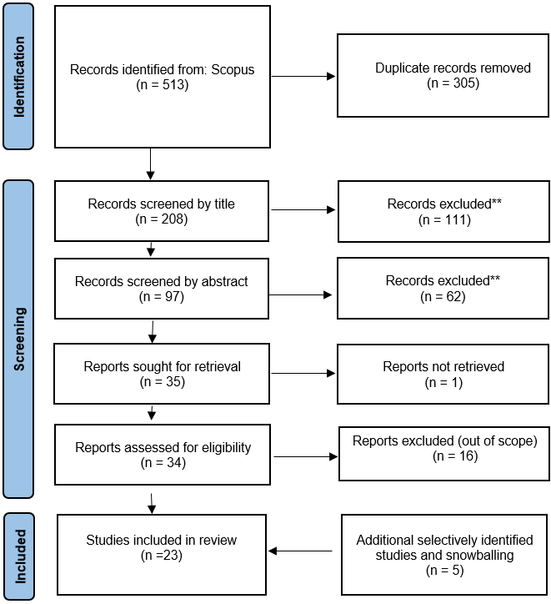

Fig.A1. Prisma flowchart

1. [MOMo Methodology Documentation](https://jthsemweblab.github.io/Integration_of_Ontology_Based_DPP_Data_into_EAM_Systems/documentations/documentation.pdf)
2. [Complete Survey Results](https://view.officeapps.live.com/op/view.aspx?src=https%3A%2F%2Fraw.githubusercontent.com%2FJTHSemWebLab%2FIntegration_of_Ontology_Based_DPP_Data_into_EAM_Systems%2Frefs%2Fheads%2Fmain%2Fsurvey%2FSurveyResponses.xlsx&wdOrigin=BROWSELINK)
3. [Ontology Modules](https://github.com/JTHSemWebLab/Integration_of_Ontology_Based_DPP_Data_into_EAM_Systems/tree/main/Ontologies)
4. [GitHub repository, Ontology-Based Approach to Integrating Digital Product Passport Data into Enterprise Asset Management Systems](https://jthsemweblab.github.io/Integration_of_Ontology_Based_DPP_Data_into_EAM_Systems/)